**AXON Sales Report Project**

**Name: Kanchan Chaudhary**

**Date: 23-11-2023**

## Project Objective:

Effectively manage and analyse the sales data to take business decisions.

## Company information:

The company name is Axon. It is a small company that manufactures miniatures of popular vehicle models. It has office locations in 5 countries and wants to manage their sales data effectively.

Database schema details:

* **Customers**: Customers are sellers of miniature vehicles. They purchase in bulk from Axon

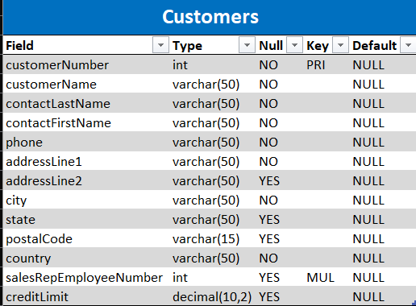

* **Products**: The product table has information about product name, product code, available quantities as well as cost

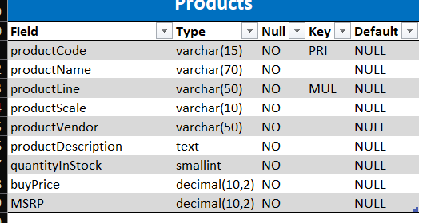

* **ProductLines**: Stores a list of product line categories

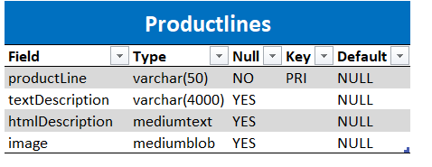

* **Orders**: Stores sales orders placed by customers

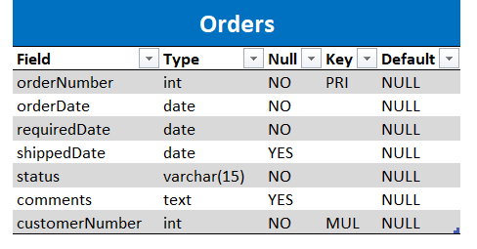

* **OrderDetails**: Stores sales order line items for each sales order.

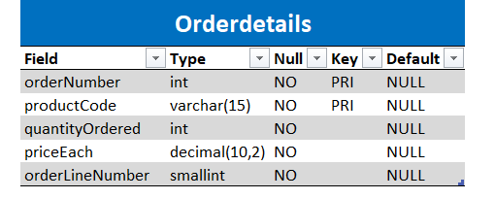

* **Payments**: Stores payments made by customers based on their accounts.

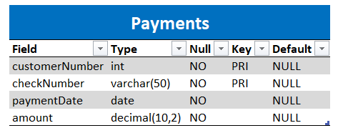

* **Employees**: Stores all employee information as well as the organization structure such as who reports to whom.

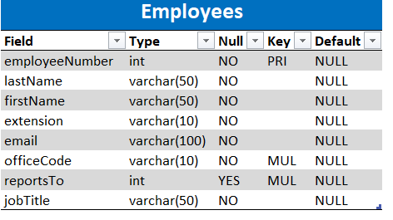

* **Offices**: Stores sales office data

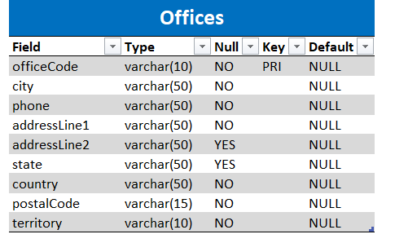

## Tools used in the project:

* MySQL 8.0
* Excel
* Power BI

## Steps taken to prepare the data:

* **MySQL**
* Data was loaded into MySQL Workbench
* Classic models database and schemas were created
* Data was inserted into the tables
* Numeric null values were replaced by 0 and text/alphanumeric null values were replaced by n/a
* Columns are joined wherever required
* Null checks implemented for future data input
* **Power BI**
  + MySQL server installed and reconfigured
  + Connected MySQL to Power BI
  + Data was loaded into Power BI desktop
  + Null values were changed
  + Duplicates removed
  + Joined address columns into one column
  + Data types checked and verified
  + Data modelling reviewed and column name changed to establish consistency in data
  + Measured table created for keeping all new measures at one place

## Making sense of report files:

### **MySQL file**

The MySQL script file contains SQL script that does the following things:

* + Show case all the properties of available schemas:

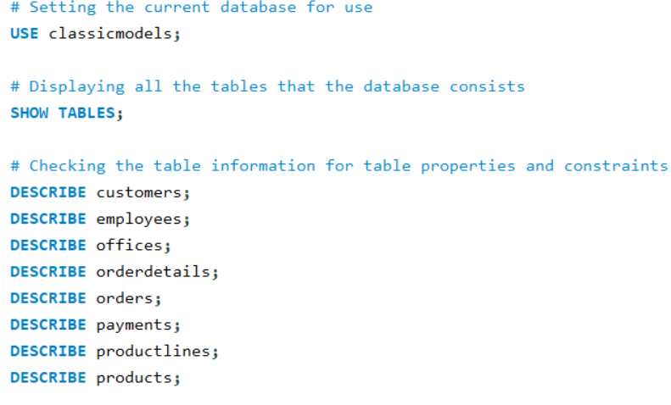

* + Showcase how to see the data in the table:  
      
    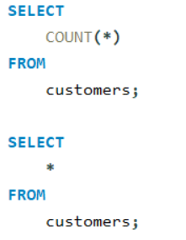
  + Create views to clean and store the cleaned data:

**Customer table view**  
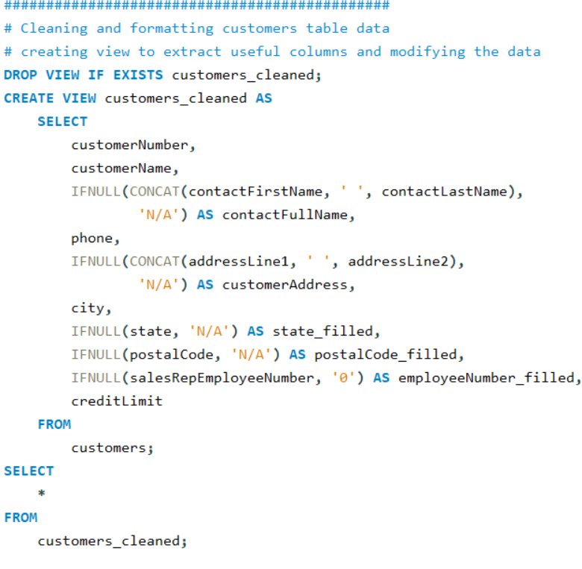

**Employees table view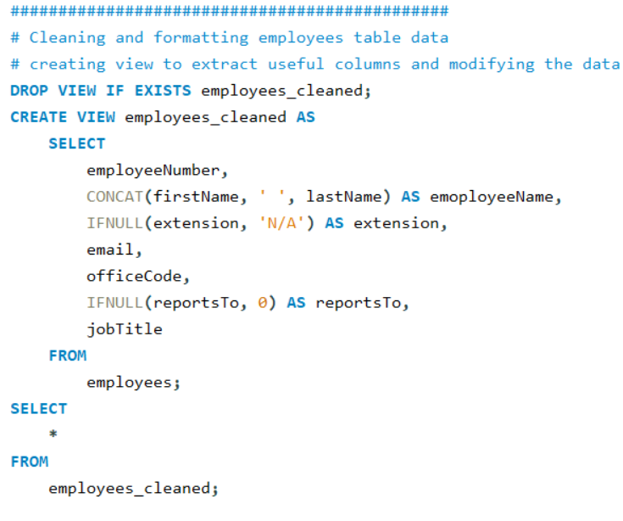 Offices table view**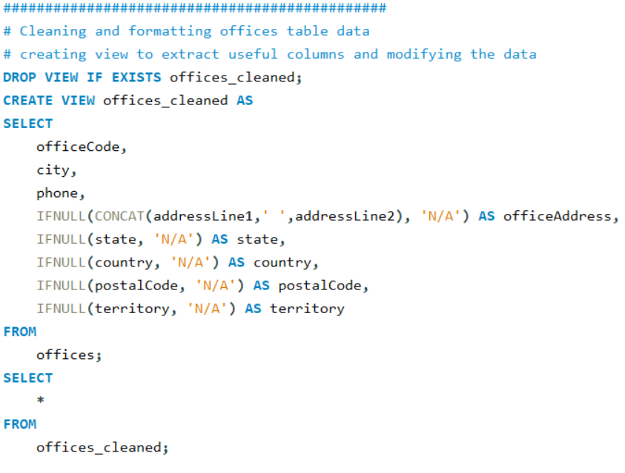

**ProductLine table view**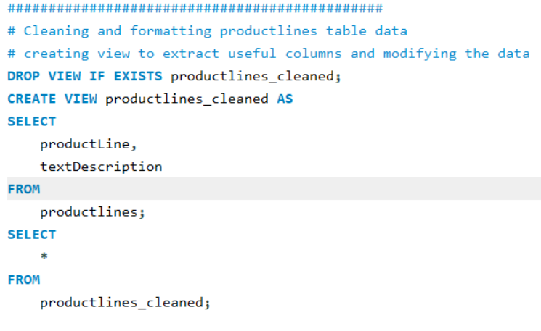

### **Excel File**

It is a replica of the database and the schemas with data in it for review and making sense of data at one place

### **Power BI Report File**

Power Bi file is showing the visualizations from data to understand the sales report quickly. It can be used by the end users. It is an interactive report that is powered to show details based on selections from the report

**Page-wise details:**

* + **HOMEPAGE:** Shows the company name with the duration of sales report that is from 06 Jan 2003 to 31 May 2005  
      
    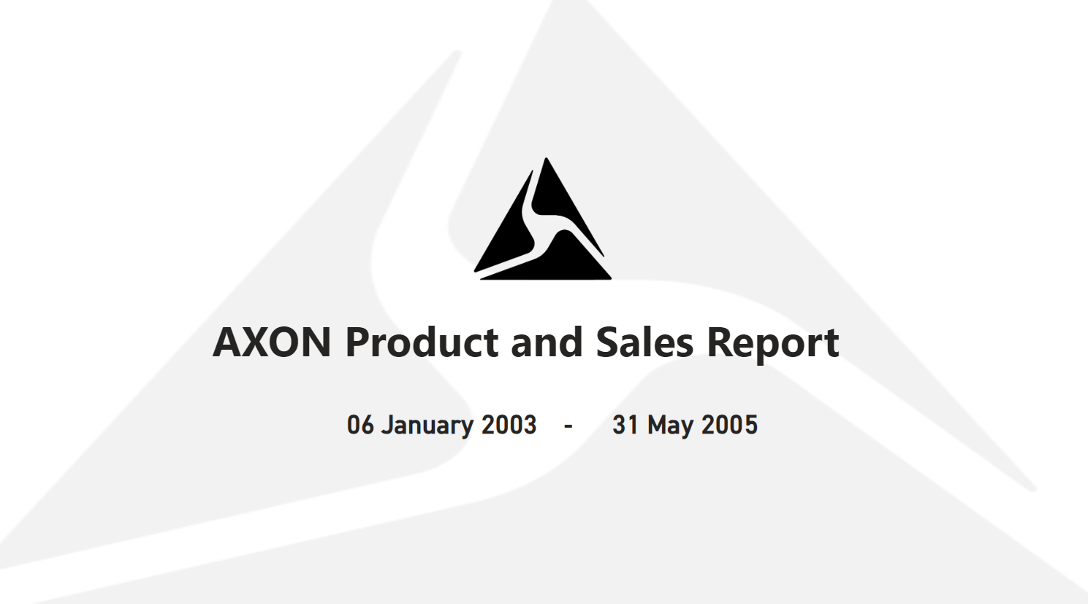
  + **OFFICES:** Shows the office locations and the global presence. Upon hovering on the visuals, it shows additional useful information based on the office locations  
      
    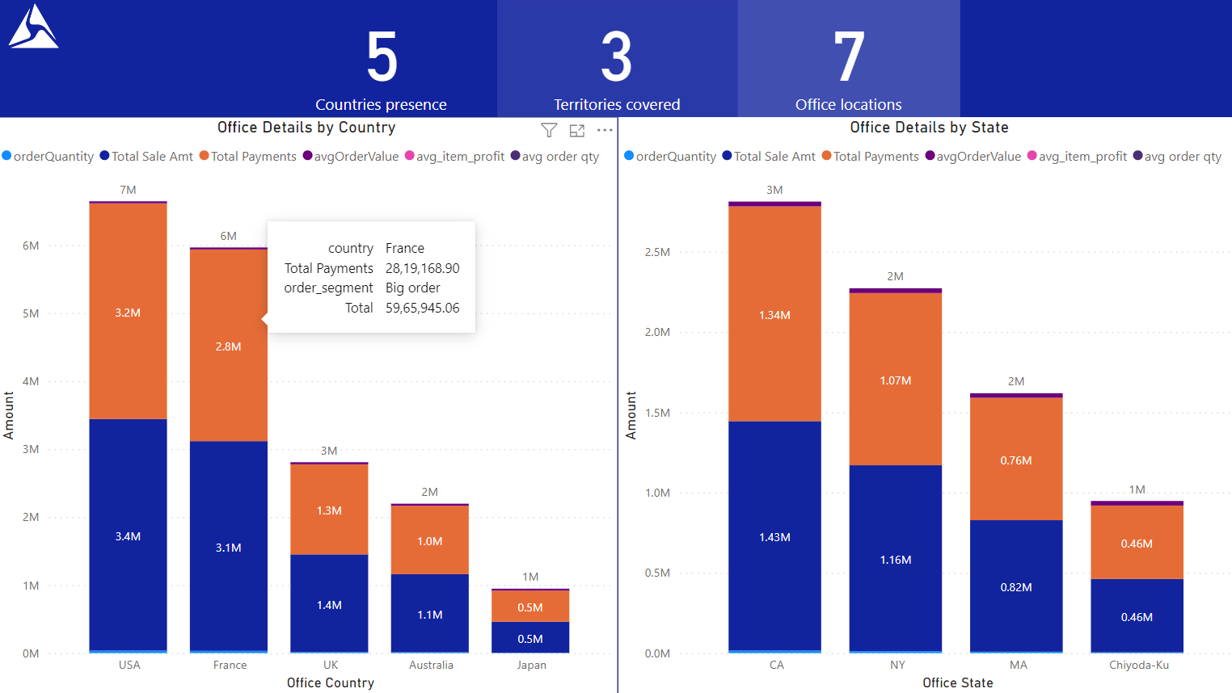
  + **CUSTOMERS:** Shows customer details, their countries, the sales amount generated by them and much more  
      
    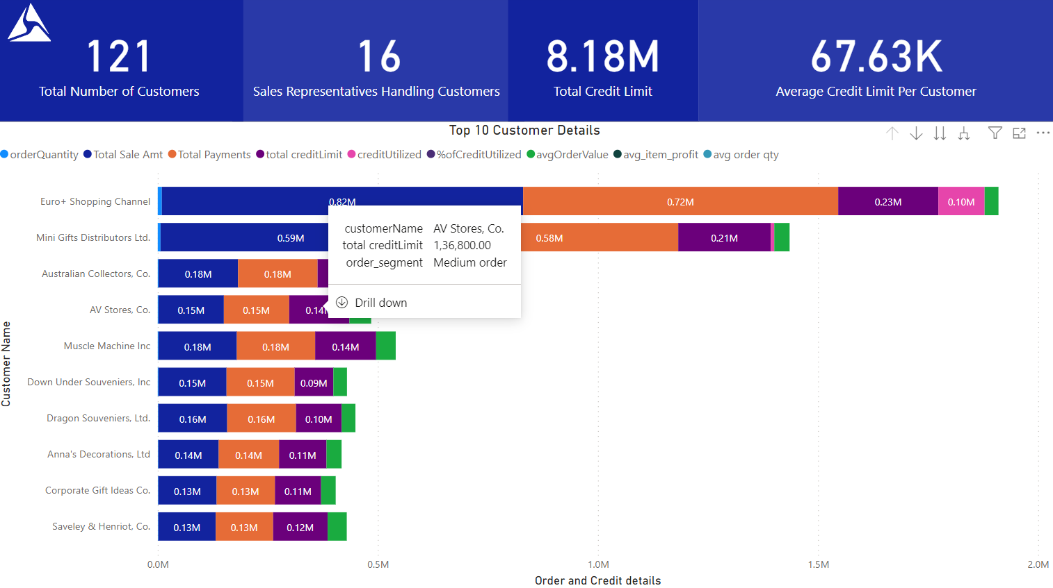
  + **PRODUCTS:** Shows product details such as categories and stock  
      
    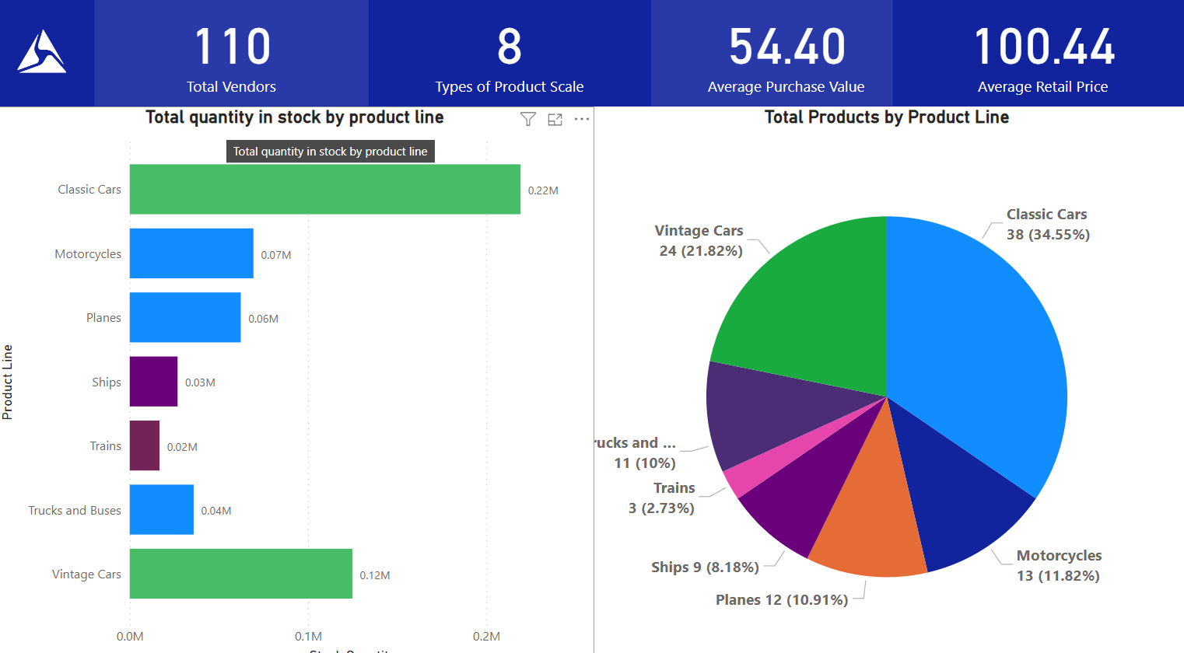
  + **EMPLOYEES:** Shows the details of Axon employees by job title, sales generated by them, customers they are handling etc.  
      
    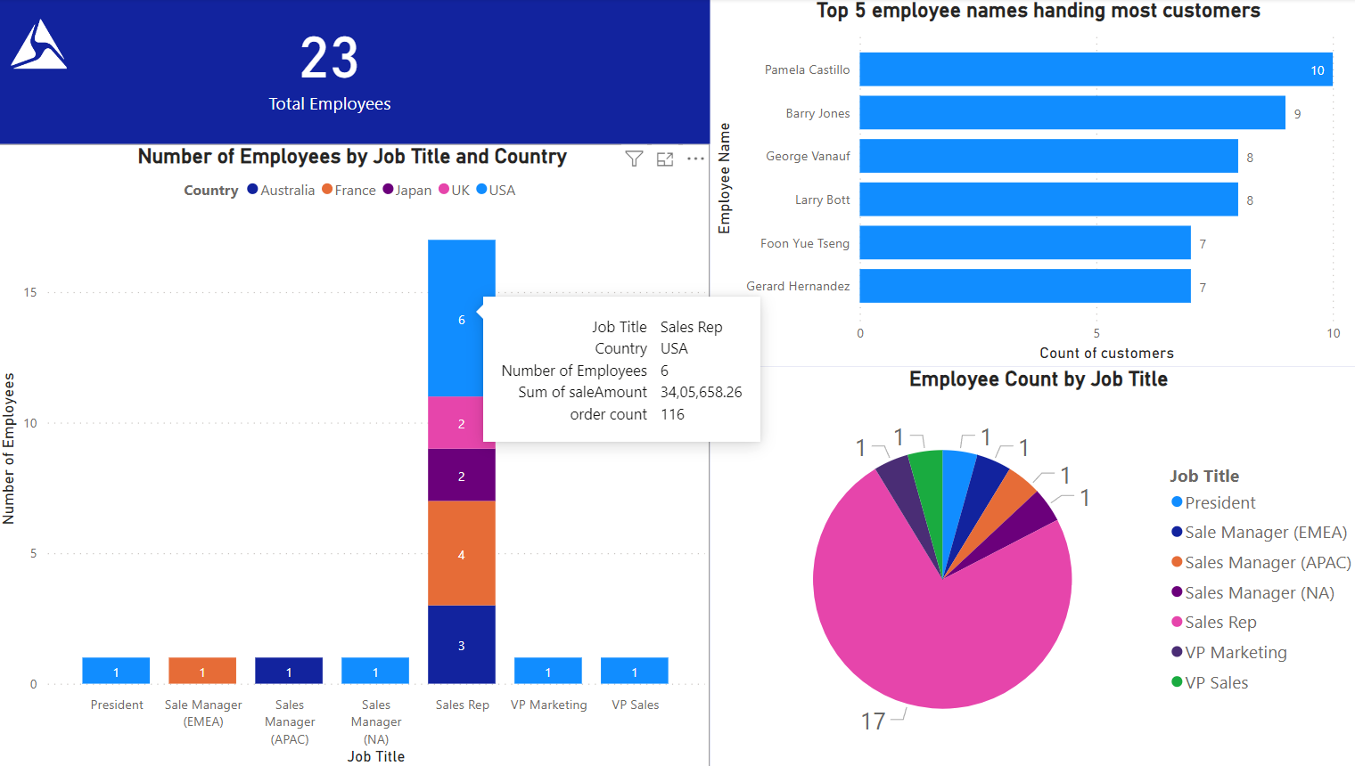
  + **ORDERS:** Shows the order details in tabular format with customer and country information   
      
    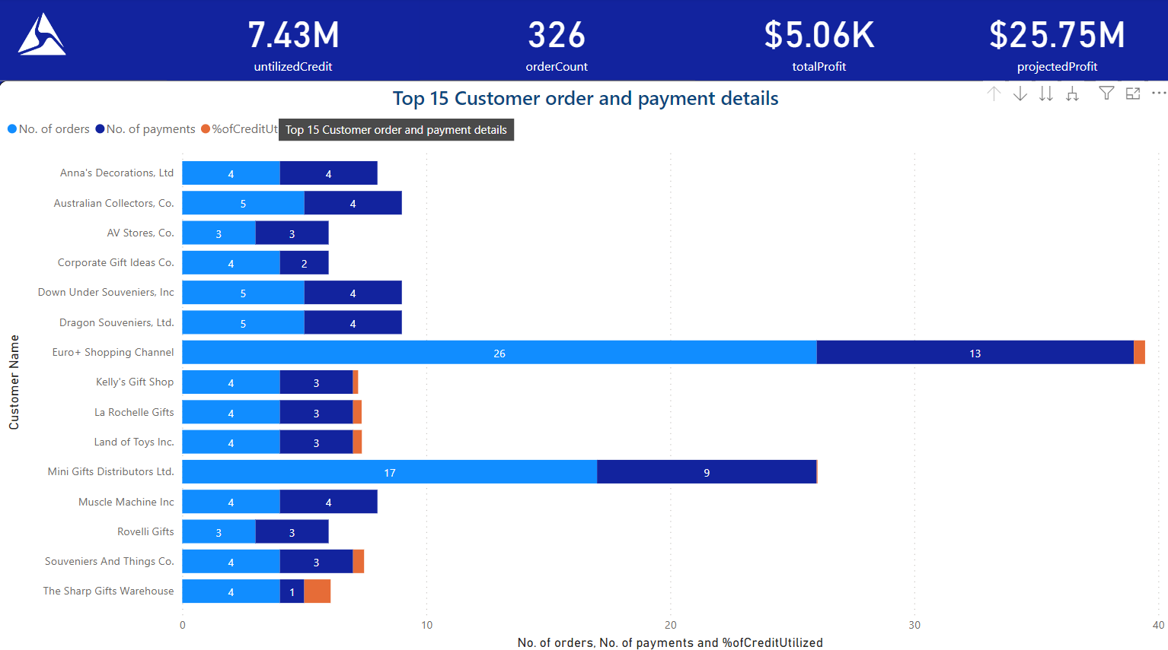
  + **SALES:** Shows sales information in tabular format. It also shows the details as per shipping status as well as vendors of Axon  
      
    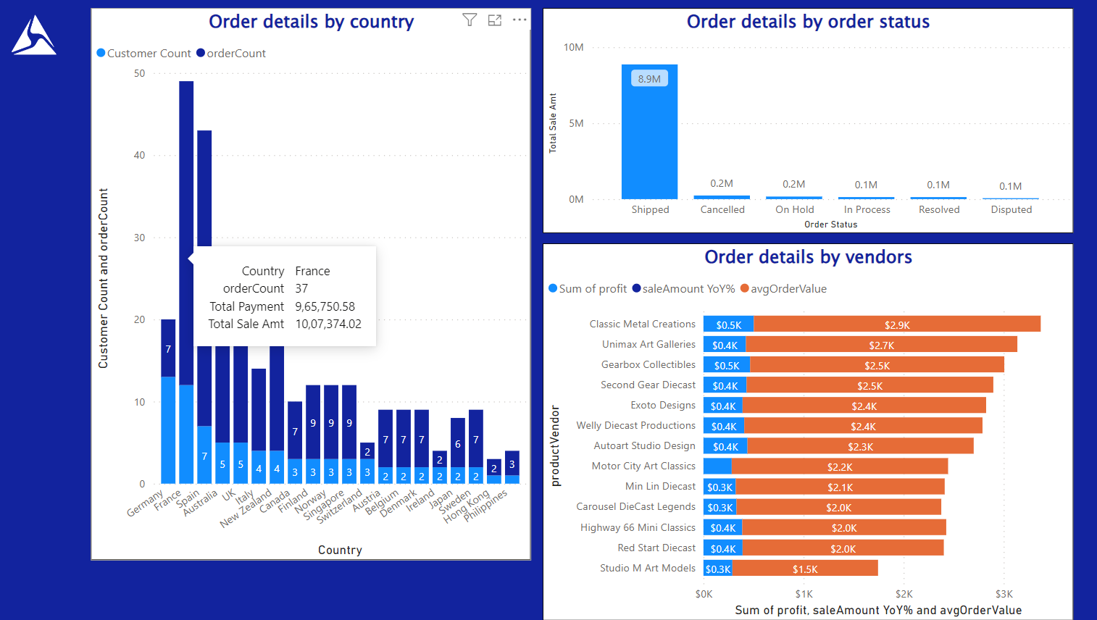
  + **CONSOLIDATES REPORT:** Shows the consolidated dashboard from the entire report. This can be used by end users to make sense of their sales trend, previous year sales as well as the total sale and profit information. The filter option is also given as drop down to filter data as per requirement  
      
    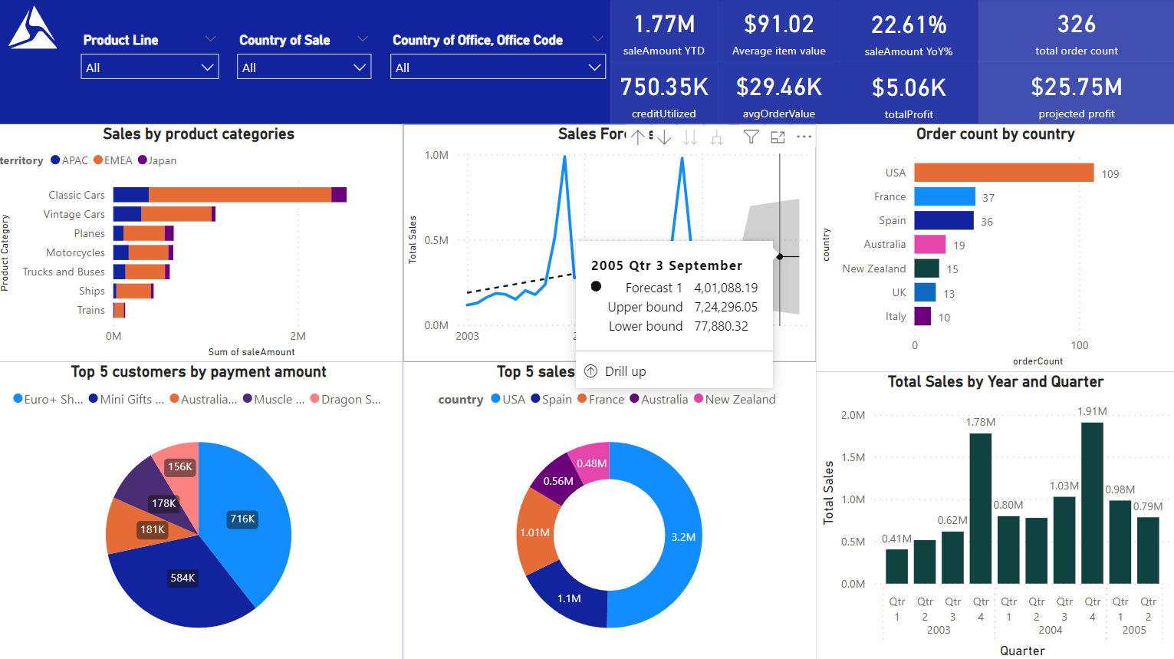
  + **KEY FINDINDS:** Shows the insights gathered from the analysis

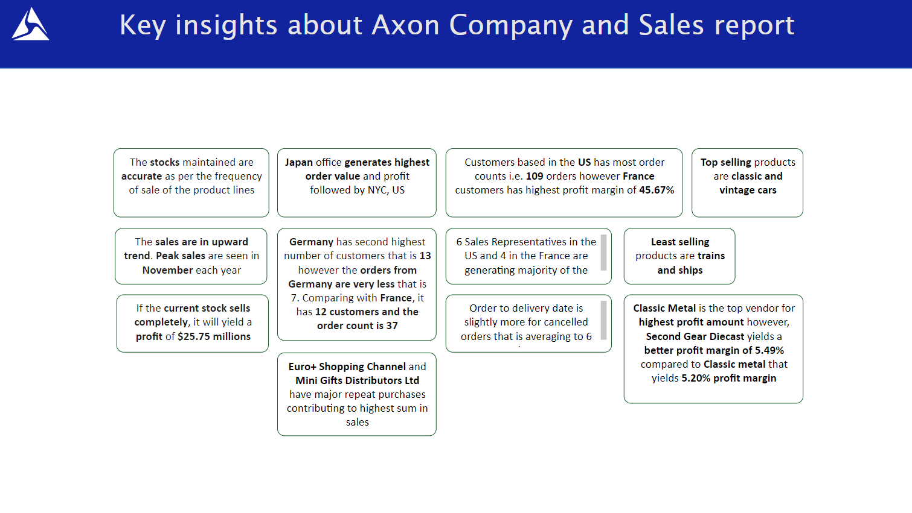

## Conclusion:

The company sales are headed in positive direction. The key focus areas are the countries and offices not performing well in terms of orders. The trains and ships product line can be re-thought as they are gathering least number of sales. Marketing campaigns can be run for France customers as they generate high order value and higher profit.